The Enrollment Guide for the “Chinese Bridge Delegation Online” Activity of Shenyang Normal University in 2020
I. Project Background
In order to maintain the learning enthusiasm of overseas Chinese learners and meet their needs of understanding Chinese language and culture, Shenyang Normal University will hold the “Chinese Bridge Delegation Online” exchange activity in 2020. We invite overseas Chinese learners to study Chinese online, experience the time-honored Chinese national culture and understand the regional culture of Shenyang, China.

II. Project Content
We will use online live courses, online activities and video courses to implement this project, designing different online groups with prominent characteristics. Each program has 40% language courses and 60% Chinese culture courses, including such traditional culture and art as Chinese language learning, Chinese Peking Opera, ethnic musical instruments, paper cutting, calligraphy, martial arts, sugar man and sugar painting, and online sightseeing activities. There are three groups including language learning, culture learning——Chinese Peking Opera and culture learning——Chinese national musical instruments.

Group One: Language learning
Date | Time  (Beijing time) | Activity Content | Remark
November 16  Monday  The first day | 17:30-18:00 | Opening ceremony
November 16  Monday  The first day | 18:00-18:45 | Chinese culture: Teaching and interactive experience of paper cutting
November 17  Tuesday  The second day | 18:00-18:45 | Chinese culture: Teaching and interactive experience of calligraphy
November 18  Wednesday  The third day | 18:00-18:45 | New Practical Chinese
November 19  Thursday  The fourth day | 18:00-18:45 | Chinese culture: Tea culture
November 20  Friday  The fifth day | 18:00-18:45 | New Practical Chinese
November 21  Saturday  The sixth day | 13:30-14:30 | Online Sightseeing on Imperial Palace
November 21  Saturday  The sixth day | 14:45-15:30 | New Practical Chinese
November 22  Sunday  The seventh day | 13:30-14:30 | Online sightseeing on Commander Zhang’s Mansion
November 23  Monday  The eighth day | 18:00-18:45 | Chinese culture: Chinese Painting
November 24  Tuesday  The ninth day | 18:00-18:45 | Chinese culture: Chinese Martial Arts
November 25  Wednesday  The tenth day | 18:00-18:45 | New Practical Chinese
November 26  Thursday  The eleventh day | 18:00-18:45 | Chinese culture: Traditional Chinese Medicine
November 27  Friday  The twelfth day | 18:00-18:45 | Chinese culture: Sugar Man and Sugar Painting
November 28  Saturday  The thirteenth day | 13:30-14:30 | Online sightseeing on Zhongjie of Shenyang
November 28  Saturday  The thirteenth day | 14:45-15:30 | New Practical Chinese
November 29  Sunday  The fourteenth day | 18:00-18:45 | New Practical Chinese
November 29  Sunday  The fourteenth day | 19:00-19:30 | Closing ceremony: Speeches making by leader and student representative

Group 2: Culture learning—— Chinese Peking Opera
Date | Time  (Beijing time) | Activity Content | Remark
November 23  Monday  The first day | 17:30-18:00 | Opening ceremony
November 23  Monday  The first day | 18:00-18:45 | Chinese course
November 24  Tuesday  The second day | 18:00-18:45 | The beauty of Peking Opera——Appreciation of facial masks
November 25  Wednesday  The third day | 18:00-18:45 | Chinese language course
November 26  Thursday  The fourth day | 18:00-18:45 | The beauty of Peking Opera——The beauty of basic skills
November 27  Friday  The fifth day | 18:00-18:45 | The beauty of Peking Opera——Appreciation of antic
November 28  Saturday  The sixth day | 13:30-14:30 | Online Sightseeing on Imperial Palace
November 28  Saturday  The sixth day | 14:45-15:30 | New Practical Chinese
November 29  Sunday  The seventh day | 13:30-14:30 | Online sightseeing on Commander Zhang’s Mansion
November 30  Monday  The eighth day | 18:00-18:45 | The beauty of Peking Opera——The meaning of performing techniques
December 1  Tuesday  The ninth day | 18:00-18:45 | The beauty of Peking Opera——Experience class on “Dan”
December 2  Wednesday  The tenth day | 18:00-18:45 | Chinese language course
December 3  Thursday  The eleventh day | 18:00-18:45 | The beauty of Peking Opera——Steps for making up a facial mask
December 4  Friday  The twelfth day | 18:00-18:45 | Chinese language course
December 5  Saturday  The thirteenth day | 13:30-14:30 | Online sightseeing on Zhongjie of Shenyang
December 5  Saturday  The thirteenth day | 14:45-15:30 | New Practical Chinese
December 6  Sunday  The fourteenth day | 18:00-18:45 | The beauty of Peking Opera——Styles of Peking Opera
December 6  Sunday  The fourteenth day | 19:00-19:30 | Closing ceremony: Speeches making by leader and student representative

Group 3: Culture learning——Chinese national instrument
Date | Time  (Beijing time) | Activity Content | Remark
November 24  Tuesday  The first day | 17:30-18:00 | Opening ceremony
November 24  Tuesday  The first day | 18:00-18:45 | Chinese national instrument——Appreciation of Bamboo flute
November 25  Wednesday  The second day | 18:00-18:45 | New Practical Chinese
November 26  Thursday  The third day | 18:00-18:45 | Chinese national instrument——Appreciation of Erhu
November 27  Friday  The fourth day | 18:00-18:45 | New Practical Chinese
November 28  Saturday  The fifth day | 13:30-14:30 | Online Sightseeing on Imperial Palace
November 28  Saturday  The fifth day | 14:45-15:30 | New Practical Chinese
November 29  Sunday  The sixth day | 13:30-14:30 | Online sightseeing on Commander Zhang’s Mansion
November 30  Monday  The seventh day | 18:00-18:45 | Chinese national instrument——Appreciation of folk percussion
December 1  Tuesday  The eighth day | 18:00-18:45 | New Practical Chinese
December 2  Wednesday  The ninth day | 18:00-18:45 | Chinese national instrument——Appreciation of Zither
December 3  Thursday  The tenth day | 18:00-18:45 | Summary of folk music
December 4  Friday  The eleventh day | 18:00-18:45 | Chinese national instrument——Appreciation of Lute
December 5  Saturday  The twelfth day | 13:30-14:30 | Online sightseeing on Zhongjie of Shenyang
December 5  Saturday  The twelfth day | 14:45-15:30 | New Practical Chinese
December 6  Sunday  The thirteenth day | 18:00-18:45 | New Practical Chinese
December 7  Monday  The fourteenth day | 18:00-18:45 | Chinese national instrument——Appreciation of Sheng
December 7  Monday  The fourteenth day | 19:00-19:30 | Closing ceremony: Speeches making by leader and student representative
* The courses schedule and teaching time may be adjusted according to the actual situation.

III. Enrollment Target and Requirements
Students are not native Speakers of Chinese and hope to learn Chinese as well as understand Chinese culture. Their age and nationality are unlimited. Each group is planned to enroll 60 to 100 students, with a minimum of 60 students. These Chinese classes will be divided into elementary, intermediate and advanced classes according to the Chinese language level of students. English teaching will be offered for cultural courses, and classes in other languages may be offered according to the enrollment situation. Each student’s online learning time is not fewer than 7 hours, and these students should actively cooperate with the teachers to complete the relevant course requirements. They will receive the study certificate after completing courses. We don’t charge students or recommended units for this activity.

IV. Registration Method and Deadline
Please fill out the Online Group Activity Students Information Summary Table (Appendix 1), and register in Chinese Bridge to complete the online registration at http://bridge.chinese.cn/online/camp by students themselves or recommended units. Each student has one account. The deadline for registration is November 14, 2020.
Contacts: Fu Hong
Telephone: +8618246070961
E-mail: huayuedongfang_11@163.com

V. Ways of Participation
Each student has an account. They should register and login the APP Club of Chinese Bridge or the Chinese Bridge official website at http://bridge.chinese.cn and then take online live courses, video courses and communication activities on time according to the course arrangement. Students also can study at home by themselves, or can be arranged by the recommended unit to participate in the online learning.

VI. The Brief Introduction of Shenyang Normal University
Shenyang Normal University, founded in 1951, is a government-funded comprehensive university. As a normal university with a long history, it has developed into a multi-disciplinary university covering nine disciplines including education, literature, pure science, engineering, management, art, philosophy, economics, law. The university has 26 secondary schools, with doctor, master and undergraduate specialized courses. There are more than 25,000 Chinese students and international students, as well as 1,289 full-time professors and teaching teachers.
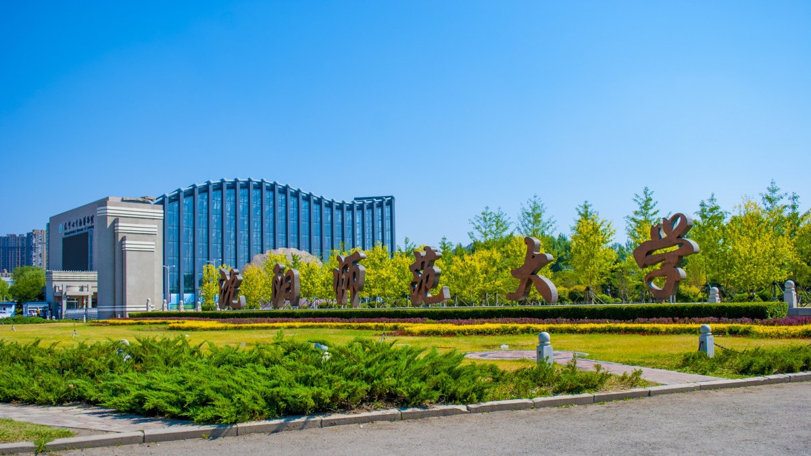

With abundant teachers of Chinese culture, Shenyang Normal University has high-quality teaching environment and beautiful university campus. This university exchanges with schools around the world on cultural and educational programs and has rich experience in receiving students and teachers from all over the world.

Shenyang Normal University
November 6, 2020

